The Astwell Benefice
Helmdon with Stuchbury and Radstone, and Syresham with Whitfield,
Lois Weedon with Weston and Plumpton and Wappenham
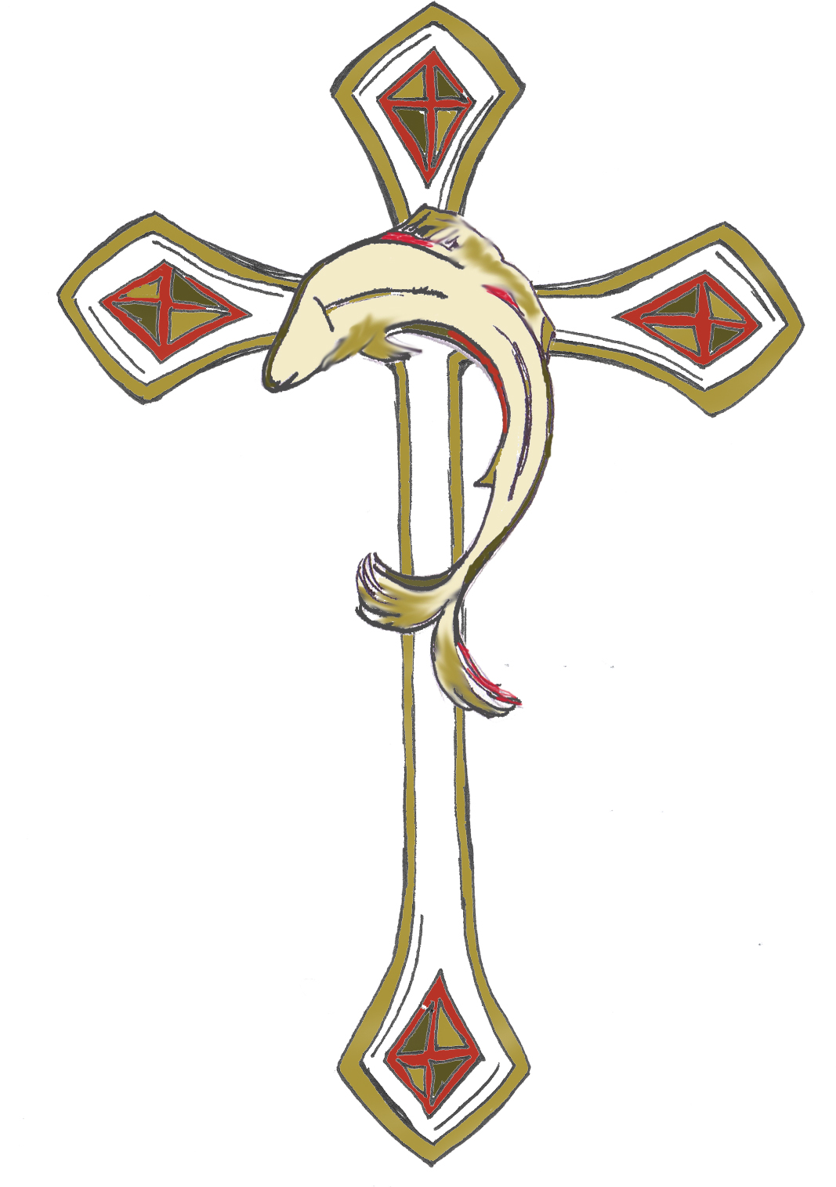

Syresham Church Council – Minutes 26/6/23
Present: Alice Palmer, Kathleen Brunning, Margaret Miller, Brenda Faragher, Sallie Connery

Apologies : David Wright, Margaret Miller

Minutes 23/3/23

Matters Arising

Parish Share £1000 was duly advanced towards our Parish Share – see financial report.

Trusts update – see below

Patronal and Harvest Festivals - The Patronal festival

Although numbers at the Harvest were fewer than hoped for we offered free refreshments to all our helpers, gave thanks for all our gifts and gave generously (£200) to the DEC disasters appeal and RABI farming charity. We also delivered 12 cards and gifts to local folk.

School Cakes. The Hammond Trust paid for staff cakes in SATS week.

Chair’s correspondence & notes
Steeple –We now have over £7,500 in the Steeple fund with £4000 promised by the Friends. The specification has at last been completed and passed to the DAC. We are awaiting final quotes in order to apply for grants.

Sycamore Tree Christian Turndrup has held his price at £840 for removing the self seeded sycamore. No-one else has been willing to quote despite 4 requests. It transpires we need a Faculty and our proposal is now with the DAC.

CWP We have our last meeting of the year on the 7th of October – though it is hoped our neighbours will burn the bonfire, later in the year. We are planning bell shaped bulbs under the tower to celebrate to celebrate the 400th birthday of some of our bells. We continue to clear, paint and destroy sycamore suckers galore…..

Other Quinquennial Simon Elbrow’s team has started work but are waiting for a final part for the tower window before completing their work.

Electrics – We are grateful to Ian Duffield and Russ Woolley for replacing the Vestry light and fixing the Belfry emergency light for FREE

Financial Report – how are we doing?

Brenda talked us through the accounts. We have paid £8,900 of our Parish Share this rises to £9,100 when money paid directly to the Benefice Account is added in. It represents 52% of the complete share. We need to raise another £2,200, alongside our regular contributions, to do better than last year. We hope to raise £1000 at the Christmas Fair and have around £1,000 in hand. Regular income has remained steady and collections are doing well. We will check the wall box as soon as Brenda can get to the key. The steeple fund stands at £7538,96. We have paid £250 to charity from the Christingle, and have another £200 to pay from the Harvest festival, this will be shared between RABI and DEC disasters fund. AP to give BF the contact details for RABI.

The £14,338 spent on Fabric includes the money for the Sound System and architects fees. The £2,014 in the churchyard includes the cutting back of Yews and the mending of the step to the churchyard, grass cutting and other maintenance.

Action BF & AP
Fund Raising

The Note-Ability concert raised £270. Due to the heat, the Fete raised only just over £900 - half the hoped for people and profits. Raffle tickets came late, the bar made a loss something strange happened with the cask of beer. However it was a lovely afternoon in the grounds of The Priory and the folk who came enjoyed the happy atmosphere. The cakes plants and bottles did well, but it was too hot for cream teas.

We agreed to keep the Christmas Fair on first Saturday in December 2-4pm.

Trust Report – accounts for Friends & Trustees

Quilter hold the Madge Payne funds and Nucleus the Maud Payne. We did have a separate financial adviser, Fortitude, over this but we found it was cheaper to ask Quilter to manage the investments for us.

We have now seen the Madge Payne Will. All the income can be spent on the church maintenance but we cannot draw down from the capital investments, which will hopefully grow, on average, to hold their value. The Maud Payne is similar but the income is solely for insurance. This means we will not always be able to rely on the full £5900 we have been receiving, we may receive more or sometimes less. The Maud Payne fund is unlikely to be able to contribute £900.

We have enough money for next year’s maintenance in place and we agreed that any money left in the Quinquennial account after Simon Elbrow has been paid would be transferred to the Steeple Fund.

We really appreciate all the hard work Brian Miller has been doing leading this group.

Upcoming Worship

All Souls November service will be on November 1st at 5:30, there are a lot of people to invite this year due to the hard time we had last year.
Remembrance will be at 10:55 by the Stone as usual.

Reverend Hugh White’s Institution will be held in Helmdon on December 7th.

Christmas: Carol by Candlelight with the chapel 6pm on December 17th, Christingles on the 24th 3 pm (the quiet one) & 4:30pm for all, 9pm Evening Communion and Family service 10:30 on Christmas Day. AP is planning a Messy Church in late November she will consult one of the mums.

AP is doing Time to Pray at 9am on a Thursday. Beryl from the chapel may join her.

Friends

The Friends are planning a Quiz in Church this Friday (6th October). They are also working on a display of knitted Poppies and War memorabilia over the Remembrance weekend.

We are most grateful for their contribution to the Steeple funds. They are also considering paying for the removal of the tree, more plants for the churchyard and the table storage box.

The Friends have two new members.

School

Brenda agreed to make a cake for the school in November. We will continue to pray for them. AP is supporting them through SIAMS. Their Harvest Festival in church was well attended in church, they brought food for the local food bank.

BF suggested we ask the Friends if any of them would like to contribute cakes for the school so that the rota goes a bit further.
Action AP

Pastoral Care
Kathleen asked that Sue Knight be added to the Christmas gifts list, as her father died in September.

SC will organise a date for the Hammond Trust fund to meet to plan Christmas gifts this year. Reverend Hugh will be invited but might not make it this year.
Action AP SC DW

Safeguarding

Sallie made a note to do some.

Action SC

AOB
Date of next meeting Monday January 22nd, 2pm @ Vine Cottage.

